**COMMUNITY PSYCHOLOGY 3600 TERM PAPER**

**QUESTIONS TO CONSIDER FOR PAPER #1**

• What is the social issue you want to address?

• What do you see as significant risk and protective factors that are relevant to this issue?

• Make sure that the risk and protective factors you have identify represent two (or possibly three) ecological systems levels and their intersections (e.g., parent’s work and how that intersects with school factors)

• Have you described these factors in community specific (rather than generic) terms?

• How might these elements identified in the community description be applied to the development of an effective community-based primary program?

• How do you involve people in the community in your program’s development?

• How is the community awareness and motivation aroused?

• Is your program tailor made to fit the community described in the first section?

• Does your program reflect a primary, prevention program? Does it reflect second order change?

• How will you increase the likelihood that the targeted group(s) to participate in the program?

• How is the message regarding this program effectively communicated?

• How does the process of determining the issue, conducting research and developing the program incorporate a minimum of five concepts and principles of community psychology outlined in the text? Identify these relevant concepts in principles in **boldface.**

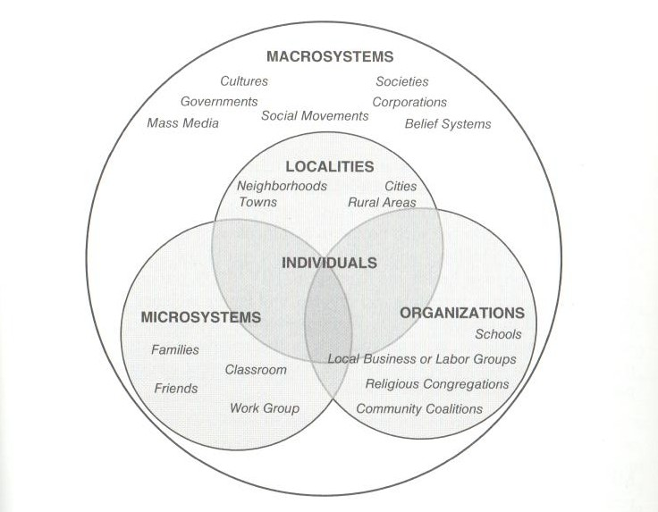

**CONSIDERATIONS FOR PAPER #2**

• What issue are you addressing?

• Ensure that you are looking at *research* (i.e., empirical) articles, *not* review articles

• Have you identified both distal and proximal risk and protective factors?

• Use Canadian research wherever possible

• Who are the participants in the articles you have cited? Make a general statement about the strengths and limitations of the samples that are used in the research articles you have cited.

• How could these empirically supported risk and protective factors guide policy development?

• Be specific:

• Policy development – do your policy recommendations follow the public policy functions outlined in Chapter 5 and in the lecture slides (i.e., instrumental purpose, conceptual purpose, persuasive mode, predictive function)

• Have you integrated into your paper five relevant community psychology principles and concepts?

• If you are making recommendations about future research, have you integrated into your paper three principles related to the kind of research community psychology recommends (i.e., action research) and how it is carried out?

